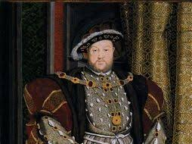

When? | Who (Subject) | Doing what?  (verb) | What? (noun) | Doing what? (verb) | Adverb | Where?
Early evening  After a few minutes  Suddenly  Some time had elapsed  Midnight  Tudor times | He  She  They  King Henry  Anne Boleyn  Will Somers  Mary | Staggered  Gasped  Wailed  Roared  Clapped  Cheated  bulged | Golden chains  Fat legs  Pile of gold  Bloated face  Velvet gowns | hanging  glistening  bloating  balancing  glaring  draping | Greedily  Politely  Heavily  Sneeringly  Slyly  carelessly | In the parlour  in the shadows  to the kitchens  in the distance  in the corner  at the table

