

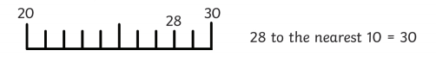

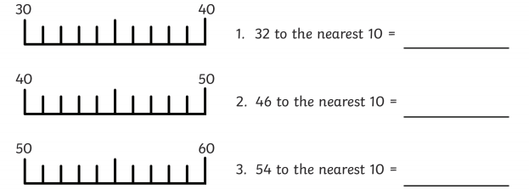

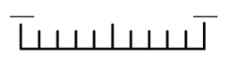

130

130

170

160

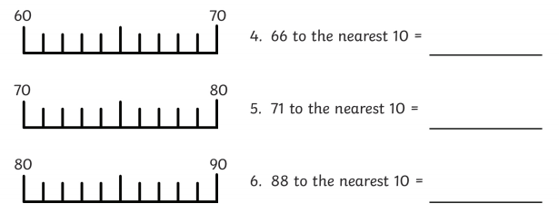





130

130

130

140

135 to the nearest 10 =

180

170

171 to the nearest 10 =

166 to the nearest 10 =



