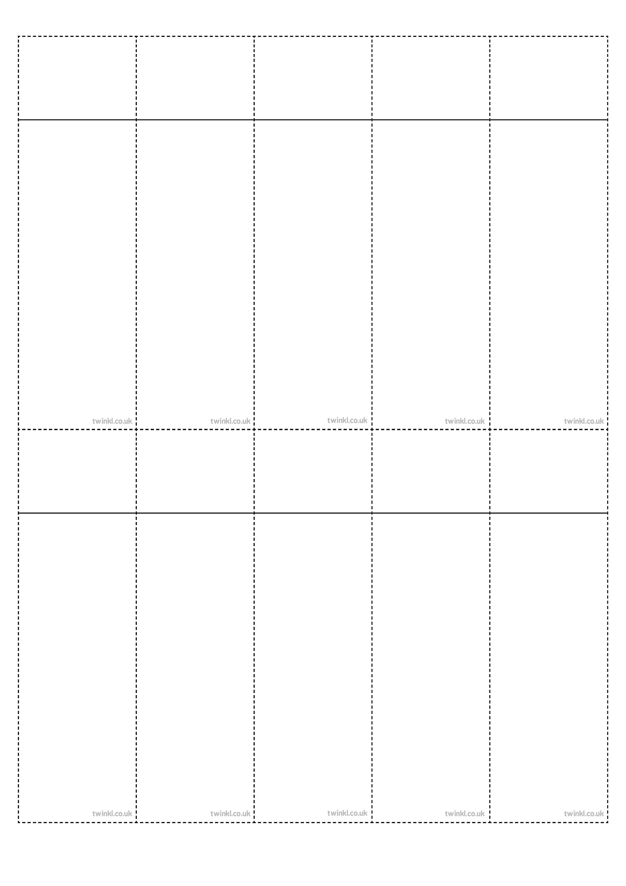
Week 3
Adding the prefix auto-
(meaning ‘self’ or ‘own’)
autograph
autobiography
automatic
autofocus
autocorrect
autopilot
autorotate
automobile
autonomy
autocue
autograph
autobiography
automatic
autofocus
autocorrect
autopilot
autorotate
automobile
autonomy
autocue

autograph
autobiography
automatic
autofocus
autocorrect
autopilot
autorotate
automobile
autonomy
autocue

autograph
autobiography
automatic
autofocus
autocorrect
autopilot
autorotate
automobile
autonomy
autocue

autograph
autobiography
automatic
autofocus
autocorrect
autopilot
autorotate
automobile
autonomy
autocue

autograph
autobiography
automatic
autofocus
autocorrect
autopilot
autorotate
automobile
autonomy
autocue

autograph
autobiography
automatic
autofocus
autocorrect
autopilot
autorotate
automobile
autonomy
autocue

autograph
autobiography
automatic
autofocus
autocorrect
autopilot
autorotate
automobile
autonomy
autocue

autograph
autobiography
automatic
autofocus
autocorrect
autopilot
autorotate
automobile
autonomy
autocue

autograph
autobiography
automatic
autofocus
autocorrect
autopilot
autorotate
automobile
autonomy
autocue

Week 3
Adding the prefix auto-
(meaning ‘self’ or ‘own’)
Week 3
Adding the prefix auto-
(meaning ‘self’ or ‘own’)
Week 3
Adding the prefix auto-
(meaning ‘self’ or ‘own’)
Week 3
Adding the prefix auto-
(meaning ‘self’ or ‘own’)
Week 3
Adding the prefix auto-
(meaning ‘self’ or ‘own’)
Week 3
Adding the prefix auto-
(meaning ‘self’ or ‘own’)
Week 3
Adding the prefix auto-
(meaning ‘self’ or ‘own’)
Week 3
Adding the prefix auto-
(meaning ‘self’ or ‘own’)
Week 3
Adding the prefix auto-
(meaning ‘self’ or ‘own’)

