[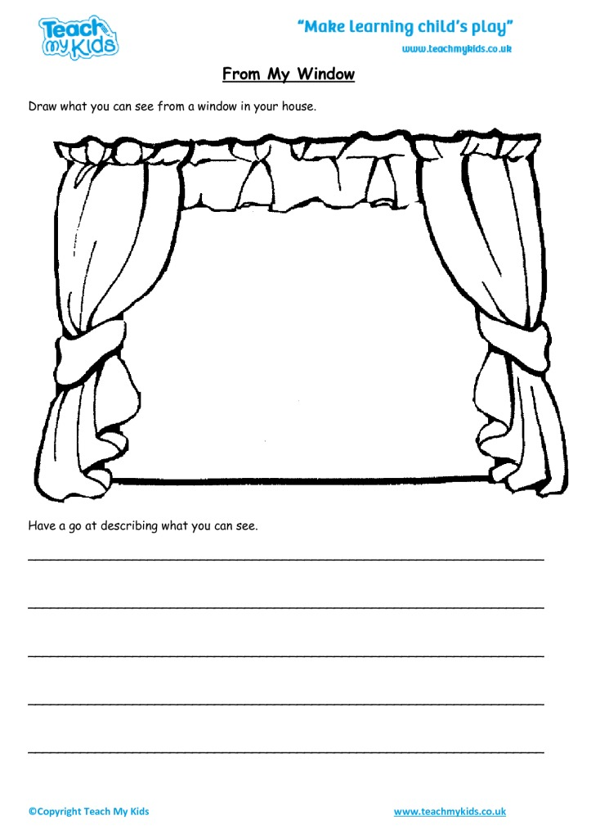](https://www.google.com/url?sa=i&url=https%3A%2F%2Ftmked.com%2Fproduct%2Ffrom-my-window%2F&psig=AOvVaw248x0fD5UZ2g2EZ6bgvUMc&ust=1586904254784000&source=images&cd=vfe&ved=0CAIQjRxqFwoTCKiK9Ja95ugCFQAAAAAdAAAAABAE)