**Year 1 Shoutouts**

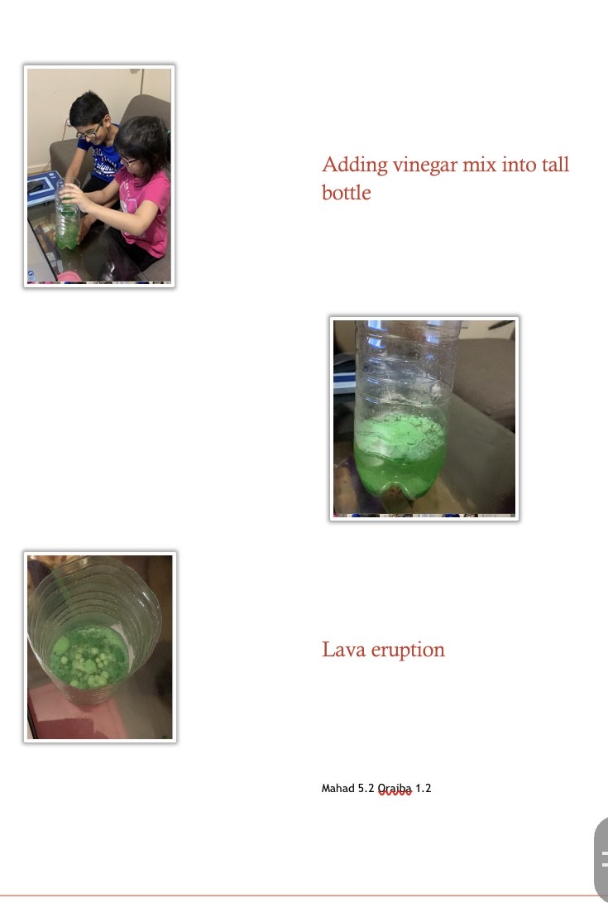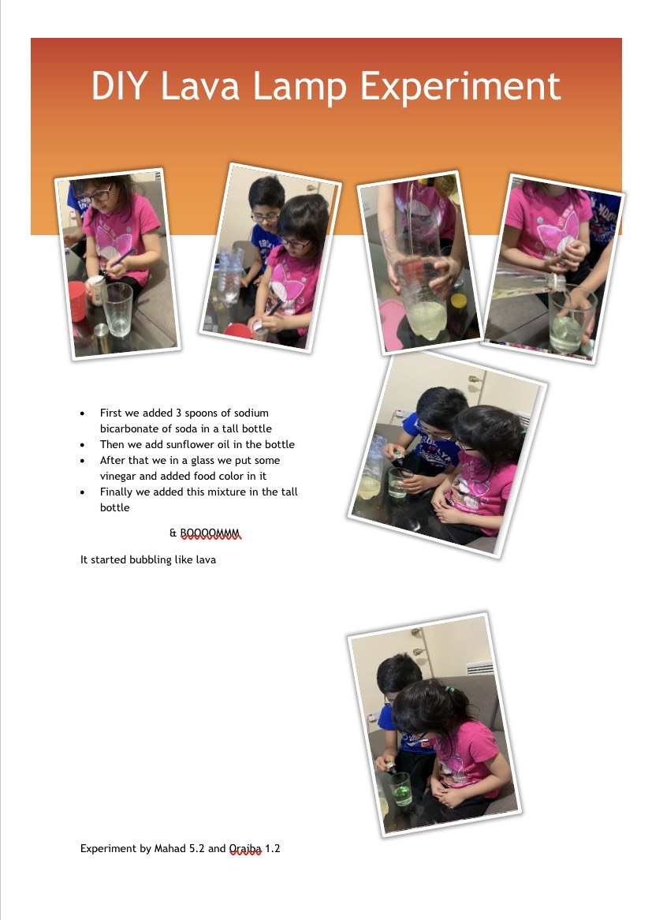

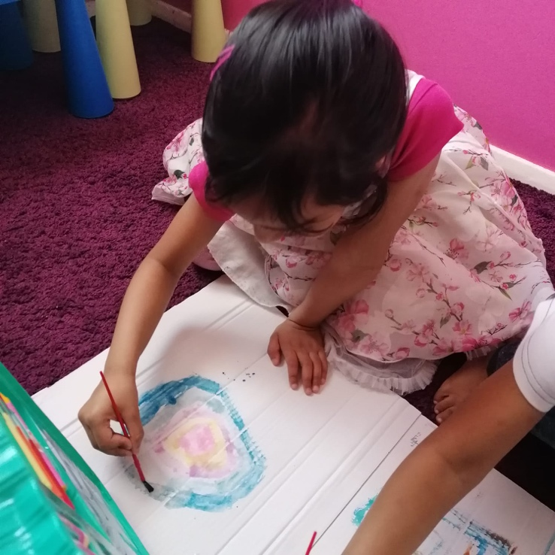

Assalamualikum All,

I hope all of you are happy and well. I miss my school and my friends. I’m helping my mom in cooking, I’m also doing my homework and having fun with my brother.

Happy birthday Mysha

I’m missing my teachers

Miss Pearce

Miss Kamran

Miss Williams

Take care All

Nabila

**Assalam o alaikum Friends,**

**Hope you guys are doing well. Today we did a fun experiment of DIY Lava Lamp. Hope you all are enjoying your time off too. I miss my school, friends and teachers.**

**STAY HOME, STAY SAFE**

**ORAIBA 1.2**



Hello to my all teachers and friends,

I miss all of you so much, please you all look after yourself, in holidays I help my mum in baking, me with my sister and brother we made yummy chocolate strawberry cake, I am sharing photos with you, I would love to see what everyone doing ☺️📚💐

Miss pierce

Miss Kamran

Miss Williams

Love to all

Ayza

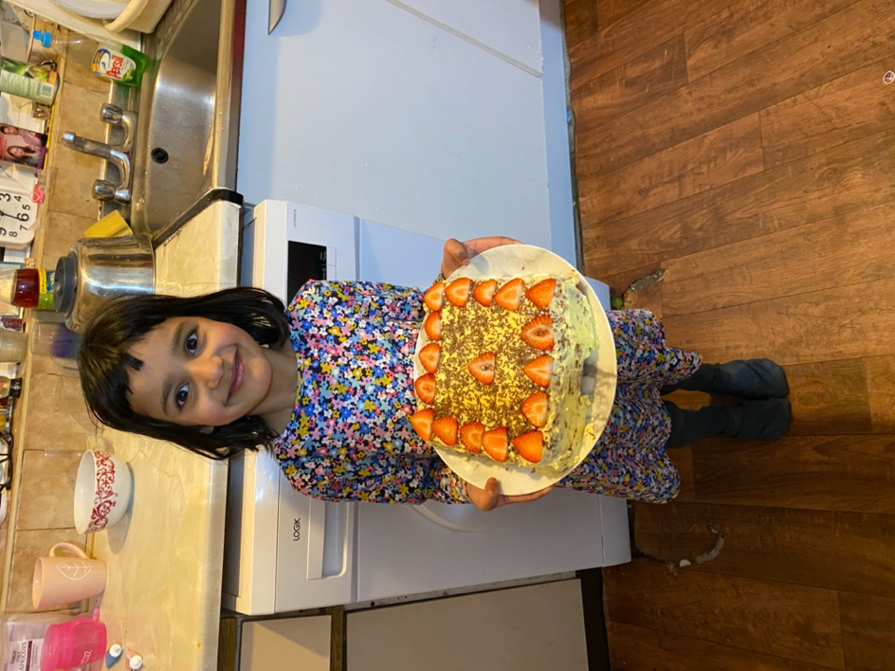

Aleena 1.3

Hello Miss Pearce  
Hope you doing good in this lockdown I miss you so much. I miss all my friends. I’m reading books & I’m helping my Mum in cleaning. Still I am bored 😐. Thank you, Nabila, for wishing me. I saw your picture. Stay safe  
Miss you all. Ramadan Mubarak Miss Kamran.  
Love from Mysha