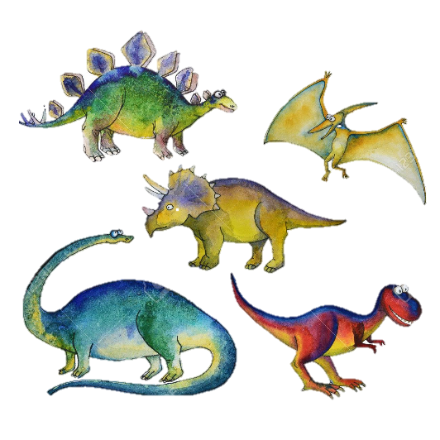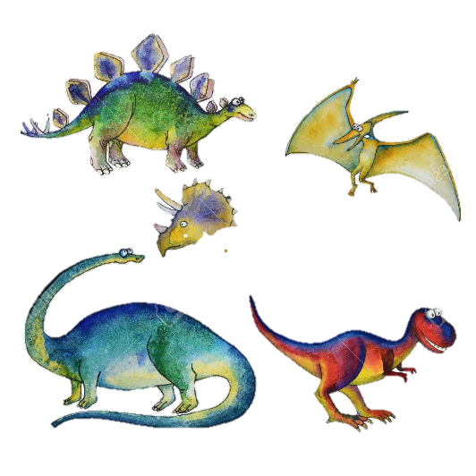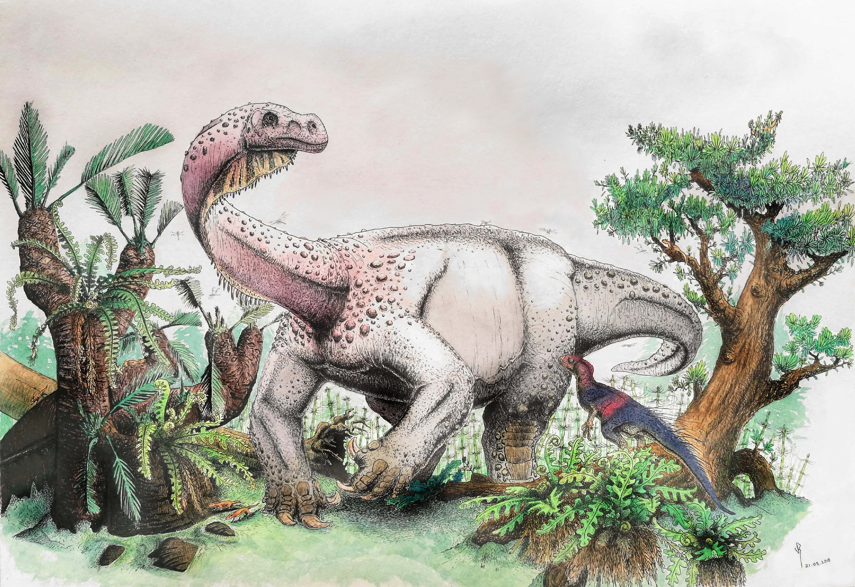

**The Jurassic Period**

**During the Spring term, Year 1 have been learning all about Dinosaurs. Your project is to research and create an information leaflet about the Jurassic period. Use the following questions as a guide:**

* **What was it like during the Jurassic period? (environment including plants and climate)**
* **When was the Jurassic period and what type of dinosaurs were around?**
* **What interesting facts do you know about the Jurassic Period?**