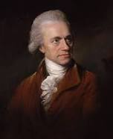
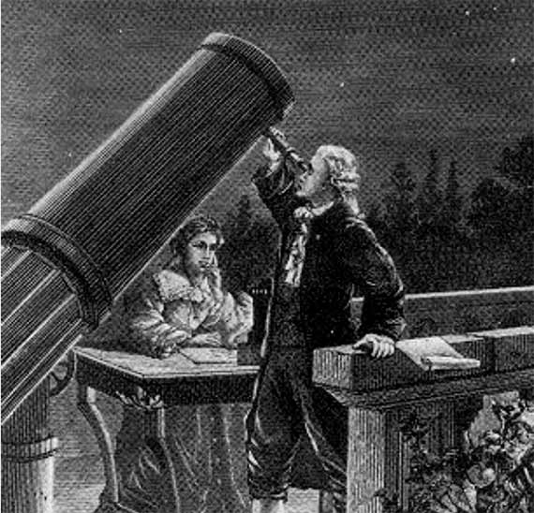
In depth historical study – Sir William Herschel

Your task is to research the life of Sir William Herschel and his influence and impact on our local area. Challenge yourself to use a wide range of sources including the internet, information books and newspaper archives. If you can visit Slough library, they may be able to support you with your research. When examining sources of information, consider their reliability and discuss this in your study.

You may like to research the following:

- Early life
- His links with Slough
- Astronomy
- Family life
- Legacy

You can present your findings as a written report or as a PowerPoint presentation which we can print off for you in school. Please ensure your project is returned to school in good condition, the first week back after the holidays.

