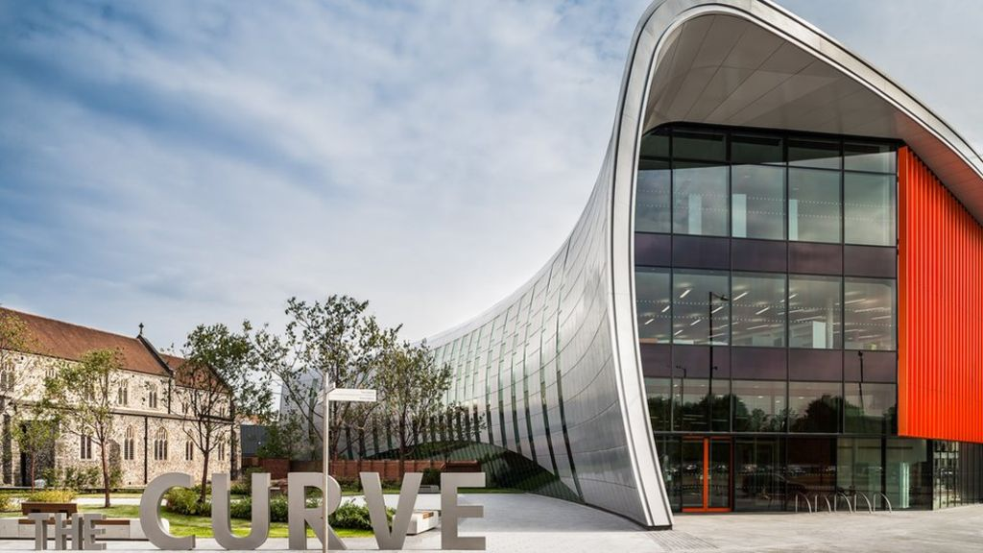
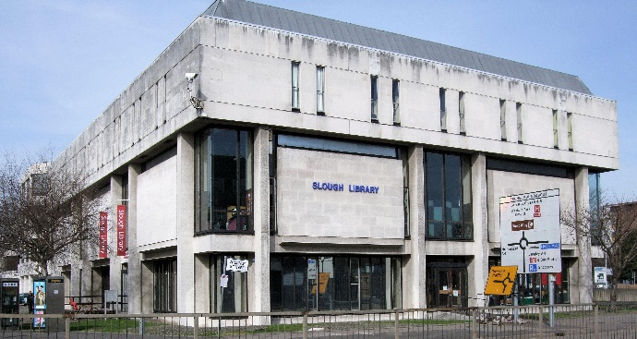
In depth historical study – Slough

Your task is to research how Slough has changed and developed over time. Challenge yourself to use a wide range of sources including the internet, information books and newspaper images. If you can visit Slough library, they may be able to support you with your research. You may want to also interview elders of the community and make notes on how their life in Slough has changed over the years.

You may like to research the following:

- Population of Slough.
- Landmarks in Slough.
- Which buildings have changed significantly over time.
- Famous people from Slough.

You can present your findings as a fact file or as a Leaflet encouraging people to visit Slough. Please ensure your project is returned to school in good condition, the first week back after the holidays.

