In depth historical study of the Ancient Egyptians
Medicine Through Time
Year 5 Summer term
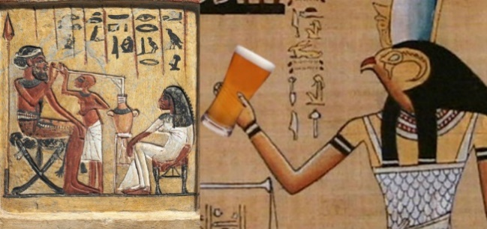

Your task is to research how Egyptians administered medicine to treat and cure the ill, and how this has changed over time to modern day medicine. Pick different eras of when medicine has changed and had an impact on society, for example after the Egyptians, came the golden age of Islam which had a significant impact on medicine, then came Alexander Fleming and the finding of penicillin, through to modern day and current medicine.
Challenge yourself to use a wide range of sources including the internet, information books and newspaper archives. When examining the sources of information, consider their reliability and discuss this in your study.
You may like to research about the following
- Ancient Egyptian medicine
- Ibn Nafis and medicine during the golden age of Islam
- Alexander Fleming and the founding of penicillin
- Modern day medicine and treatments.

You can present your findings as a written report or as a PowerPoint presentation which we could print off for you in school. Please ensure your project is returned to school in good condition the first week back after the break.

