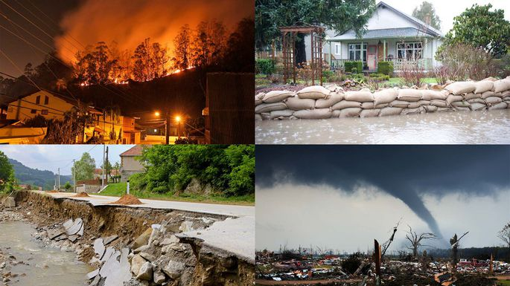

Year 3 - Autumn 2 – Natural Disasters

**Cross Curricular: Science:**

Pupils will be learning about rocks

**NC Objectives:**

* To compare and group together different kinds of rocks on the basis of their appearance and simple physical properties
* To describe in simple terms how fossils are formed when things that have lived are trapped within the rock
* To recognize that soils are made from rocks and organic matter

**Cross Curricular: Writing:**

Pupils to write a short story based on natural disasters in relation to their Narrative Adventure unit.

**NC Objectives:**

* To use expanded noun phrases effectively to add detail
* To spell majority of the Year 3/4 common exception words and tier words correctly
* To use paragraphs to organise ideas
* To use prepositions to describe settings

**Cross Curricular: Reading:  
Fiction: Vacation Under the Volcano**

**Non-Fiction: Natural Disasters**

**NC Objectives:**

* I can maintain a positive attitude to reading by understanding what I have read and identifying a theme in the book
* I can discuss words that attract the readers’ attention, interest and imagination
* I can retrieve and record information
* I can read with expression
* I can find the meanings of unfamiliar words  
  I can independently check the text makes sense by reading the sentences before and after

**PSHE:**

Emotional well-being

**NC Objectives:**

* I know how to express my feelings and emotions
* I know the importance of having empathy
* I can identify positive ways to face new challenges

**Geography NC Objectives:**

* **To identify the different structures of the earth.**
* **To understand have earthquakes occur**
* **To understand plate tectonics**
* **Ask simple geographical questions e.g.: what is it like to live in this place?**
* **To identify the different types of volcanoes**

**Cross Curricular: Design and Technology**Pupils will be creating their own volcano models using a range of materials. They will then have the opportunity to explode them, creating a chemical reaction. They will then

* To design and evaluate the work of their own and their peers
* To know the names of tools, techniques and elements used
* Use artwork skills to record ideas, observations and experiences