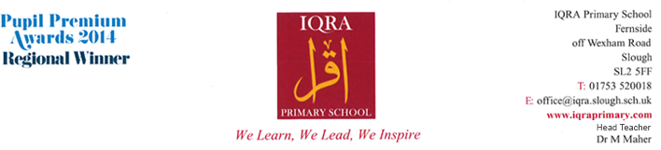**CURRICULUM NEWSLETTER**

**YEAR 1**

**AUTUMN TERM 2 2018**

Dear Parents / Carers,

Please find below the units that your child will be learning this term.

**English**

* **Narrative**-The focus text is ‘Snowflakes’. The children will begin by focusing on unfamiliar words from the story and apply the new words learnt in their writing. We aim to use the text as a stimulus to write a short narrative with an alternative setting. Throughout the unit of work, the children will participate in role play and drama activities.
* **Non-fiction**- To write an explanation text about Seasons.
* **Phonics** – Will be taught through the Read Write Inc scheme. The children will develop their knowledge and understanding of phonics. They will learn to apply the skills learnt in their reading and writing.
* **Grammar focus**: We will be developing children’s grammatical skills. We will be focusing on using capital letters and full stops to punctuate a sentence.

**Maths**

* Identify and recognize the properties of 2D shapes
* Identify and recognize the properties of 3D shapes
* Place value-Finding different ways to make a number
* Add and subtract 1 digit and 2 digit numbers using different strategies
* Know numbers facts to 10 and 20
* Identify numbers that are greater than and less than a given number.

**We will continue to deepen children’s understanding of concepts through a variety of reasoning and problem solving tasks.**

**Science**

**Plants**

* Use simple equipment to observe closely
* Identify and name a variety of common wild and garden plants, including deciduous and evergreen trees
* Identify and describe the basic structure of a variety of common flowering plants, including trees
* Grow a plant and understand the conditions needed for it to grow well.

**Arabic Studies**

**The Arabic Alphabet & Numbers (0-10):** Pupils in year 1 will begin the term reviewing the Arabic alphabet and consolidating what was covered in reception. The focus this term will be on identifying and writing partial Arabic letters (joint letters) in preparation for future written work. This is a long term plan which will continue into future topics. Later in the term, pupils will learn how to count from 0 - 10.

**R.E**

Key Beliefs: The children will explore the 5 pillars of Islam and expand on the topic of Hajj. They will learn the Story of Ismail AS and the Zam Zam. They will be able to identify the different parts of the Kabah.

**PE**

Sports covered this term will be: **Netball, Gymnastics**

The pupils will be exploring different ways in which to move. They will be working on their Agility, Balance and Co-Ordination skills through individual work and by learning to work as a team

The pupils will also be learning the importance of living a healthy life style, looking at key elements in their diet such as: Sugar /Salt / Oil. The understanding of how important it is to raise their heart rate.

**PE**

**PE**

**PE**

**Additional Information**

All children should have the school PE kit as this is part of their uniform. This **must** include trainers or plimsolls. Children are not allowed to do PE in their school shoes.

**The children need to come to school in their uniform and will leave school in their PE kit.**

**Homework-** Homework will be given out on a **Friday and will need to** be completed by the following **Tuesday** and brought in for marking. Please encourage children to independently complete homework as it will be set according to what is being learnt in class and will help reinforce and embed the learning.

**Also could you please ensure that your child only completes the highlighted pages only. Any extra work you wish for your child to complete will need to be sourced from yourselves.**

We hope you find this information useful and that you are able to use it to support your child’s learning at home.

Yours faithfully,

The Year 1 team,

Ms. Rafique/Ms Cooper, Ms. Verma and Mr. Mahmood

