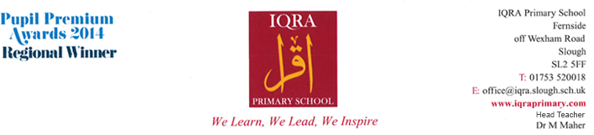
Required for September 2023
Teaching Assistant Vacancies
(Classroom & SEN 1:1)
Salary dependent on experience

Do you want to make a difference? We are looking for enthusiastic and flexible staff members to work within our well established, thriving and lively team
We welcome applications from Graduates with a pathway to progress over time.
Contract: Fixed Term

The main duties will be:
- Support teaching and learning
- Supporting the class teacher
- Assisting with the preparation of the learning environment
- Planning learning activities with the class teacher
- Liaise with the teachers, Inclusion Manager and parents, carry out observations and report writing
- Assisting with the development of children in literacy, numeracy and other aspects of the National Curriculum

The main duty of the SEN post primarily will be one to one support of a Special Needs child, but will also include duties detailed for the TA role.

Candidates must have:
- A proven track record of supporting pupils and teachers in a class-based context
- Minimum of NVQ2 (or equivalent) and working towards NVQ3
- Minimum 6 months working experience in this field
- For the position(s) which require working on a one-to-one basis with Special Needs children – appropriate experience will be required.

You will work 33.5 hours per week, 8.30am–3.30pm Monday to Friday, to include a lunch time duty each day plus one-hour training per week, term time only (plus 5 INSET days).

We offer:
- A positive and caring ethos and working atmosphere
- Friendly children, eager to learn and achieve
- A committed, enthusiastic and supportive staff team
- Excellent support from the Governing Body, the staff and parents
- An excellent opportunity for professional and career development

If you have the enthusiasm and commitment to contribute to the ongoing development of this successful, friendly and supportive school, we would like to hear from you.

IQRA Primary School is committed to safeguarding and promoting the welfare of children, young people and vulnerable adults. We expect all staff and volunteers to share this commitment. An enhanced DBS disclosure will be required for the successful candidate in accordance with Safeguarding Children and Safer Recruitment in Education Legislation.

Closing Date: Midday Friday 28th April 2023

For an application pack please download from the school website or alternatively please email pa@iqra.slough.sch.uk A classroom observation will form part of the interview process. Please note that CVs are not accepted. Previous applicants need not apply.

