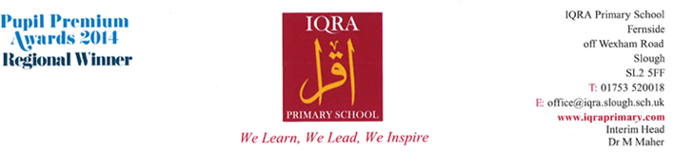**CURRICULUM NEWSLETTER**

**YEAR 4**

**Autumn 1 – 2022-23**

Dear Parents / Carers,

Please find below the units that your child will be learning this term.

**Writing**

Text types: character description and diary entry

* Grammar focus: As well as using capital letters and full stops to punctuate a sentence, children will also be introduced to a range of other punctuation in order to up level their writing.

**Maths**

**Place value**

* Read, write, order and compare numbers to 1000 and beyond.
* To find 1000 more/less than a given number.
* Identify and represent numbers using objects.
* Count in multiples of 6,7,9,25 and 1000-forwards and backwards
* Use a number square and number line to count forwards and backwards- including negative numbers.
* Understand place value – what each digit in a number means.
* Addition and subtraction 4 digit numbers.
* To solve problems using abstract and practical methods.
* To recall multiplication and division facts up to 12x12.

**Reading**

Focus text: Beowulf by Michael Morpurgo.

* In reading children will be covering a variety of reading skills and test style questions in preparation for their end of term assessments.
* Phonics - children will continue with the scheme Read, Write Inc. They will apply these skills in both their reading and writing.

**MFL - Arabic**

**Myself & Others > Likes & Dislikes**

Autumn term will begin with Year 4 covering the topic of myself and others. Although the pupils have covered the topic on a very basic level, the aim now is to enable students to give extended answers to questions and have deeper conversations. Students will also learn how to use possessive nouns as well as revise rules on gender with Arabic nouns. Following on from ‘Myself & Others’’ where children learnt how to introduce themselves and their family members, pupils will spend the second term learning how to discuss hobbies and interests. This will involve expressing likes, dislikes, preferences and reasons for them. Grammar focus will be on adjectives and conjunctions.

**Science**

**Animals, including Humans**

* The digestive system in humans
* Functions of the parts of the digestive system
* Comparing animal and human digestive systems
* Types of human teeth
* Investigation on tooth decay
* Food chains

**PE**

**PE**

**PE**

**PE**

**The pupils will explore a how to sequence a range of movement patterns to form a routine. Linking in with their topic on the Anglo Saxons.**

**Character Values – Kindness & Friendship**

The pupils will gain inspiration from history (Anglo Saxons – Topic) and be able to link a series of movement patterns with fluently and control bringing

their topic to life. The pupils will be able to perform in front of their peers a small routine.

The pupils will also be learning the importance of living a healthy life style, looking at key elements in their diet such as how vitamins and minerals play an active role.

**R.E**

Key Beliefs: The children will explore the articles of faith. They will focus on the belief of life after death. They will explore Islamic texts which describe the Angels and the sacred books in Islam.

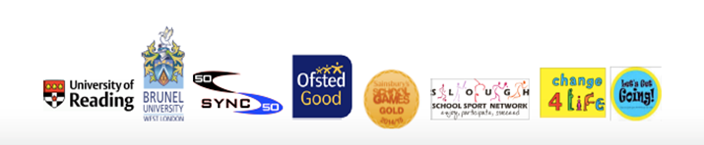

**Additional Information**

All children should have the school PE kit as this is part of their uniform. This **must** include trainers or plimsols and the new burgundy PE shirt. Children are not allowed to do PE in their school shoes.

This term children need to bring in their PE kits to school on a **Wednesday**. Any child who comes to school not wearing their school uniform will be sent to the office and their parents/cares will be called to bring it in.

**Homework-** we have ordered homework books for each child**. Homework will need to** be completed by the following **Tuesday**. Please ensure that your child only completes the pages that have been set as these books should last for the whole year. Please encourage children to independently complete homework as it will be set according to what is being learnt in class and will help reinforce and embed the learning.

We hope this information is useful to you.

The Year 4 team,

Mr Mahmood, Ms Raza and Mrs Saqlain